**View 1: Sales Revenue**

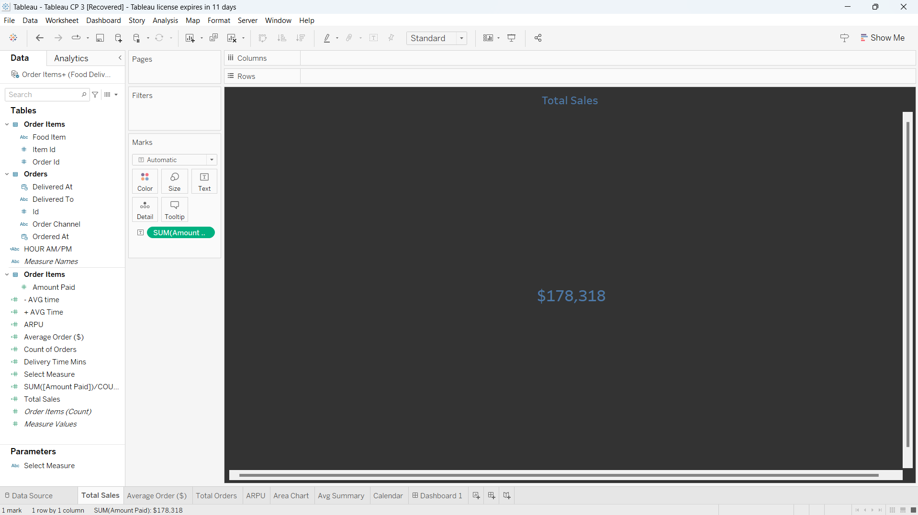

**View 2: Average Order ($)**

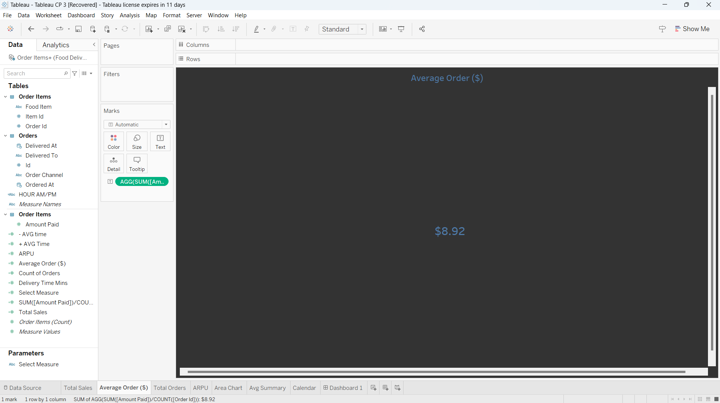

**View 3: Total Orders**

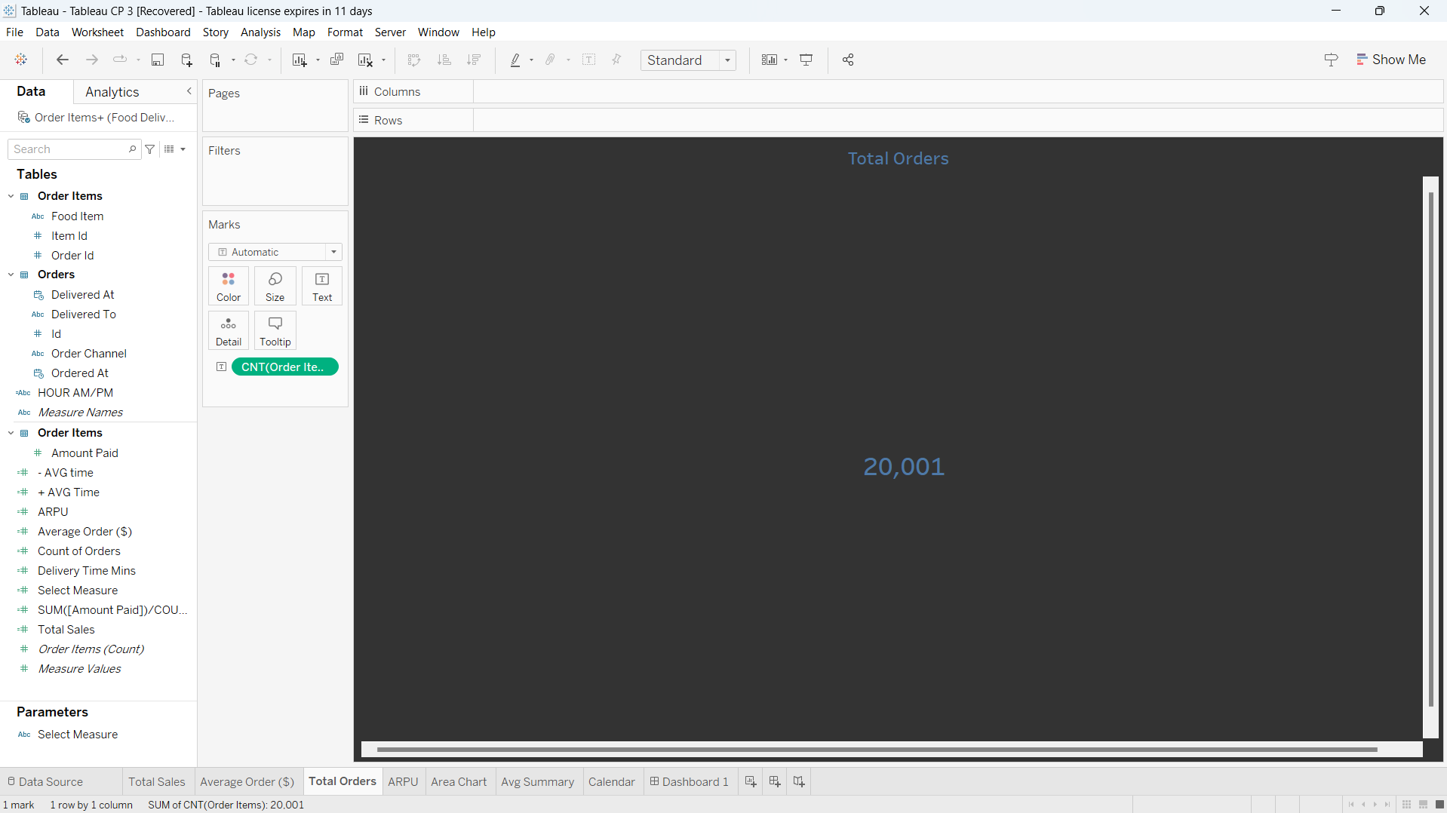

**View 4: ARPU**

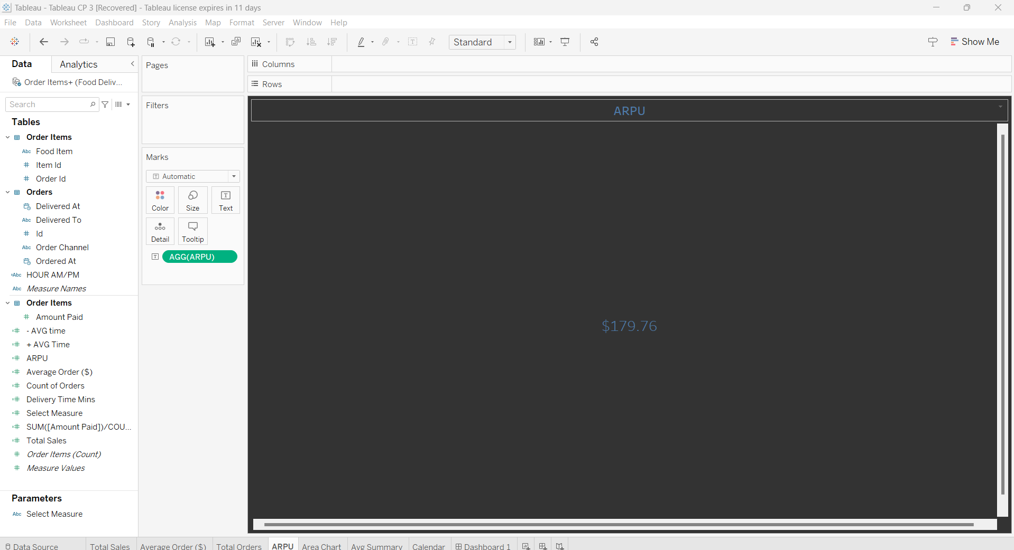

**View 5: Area Chart showing Daily Trending Metrics**

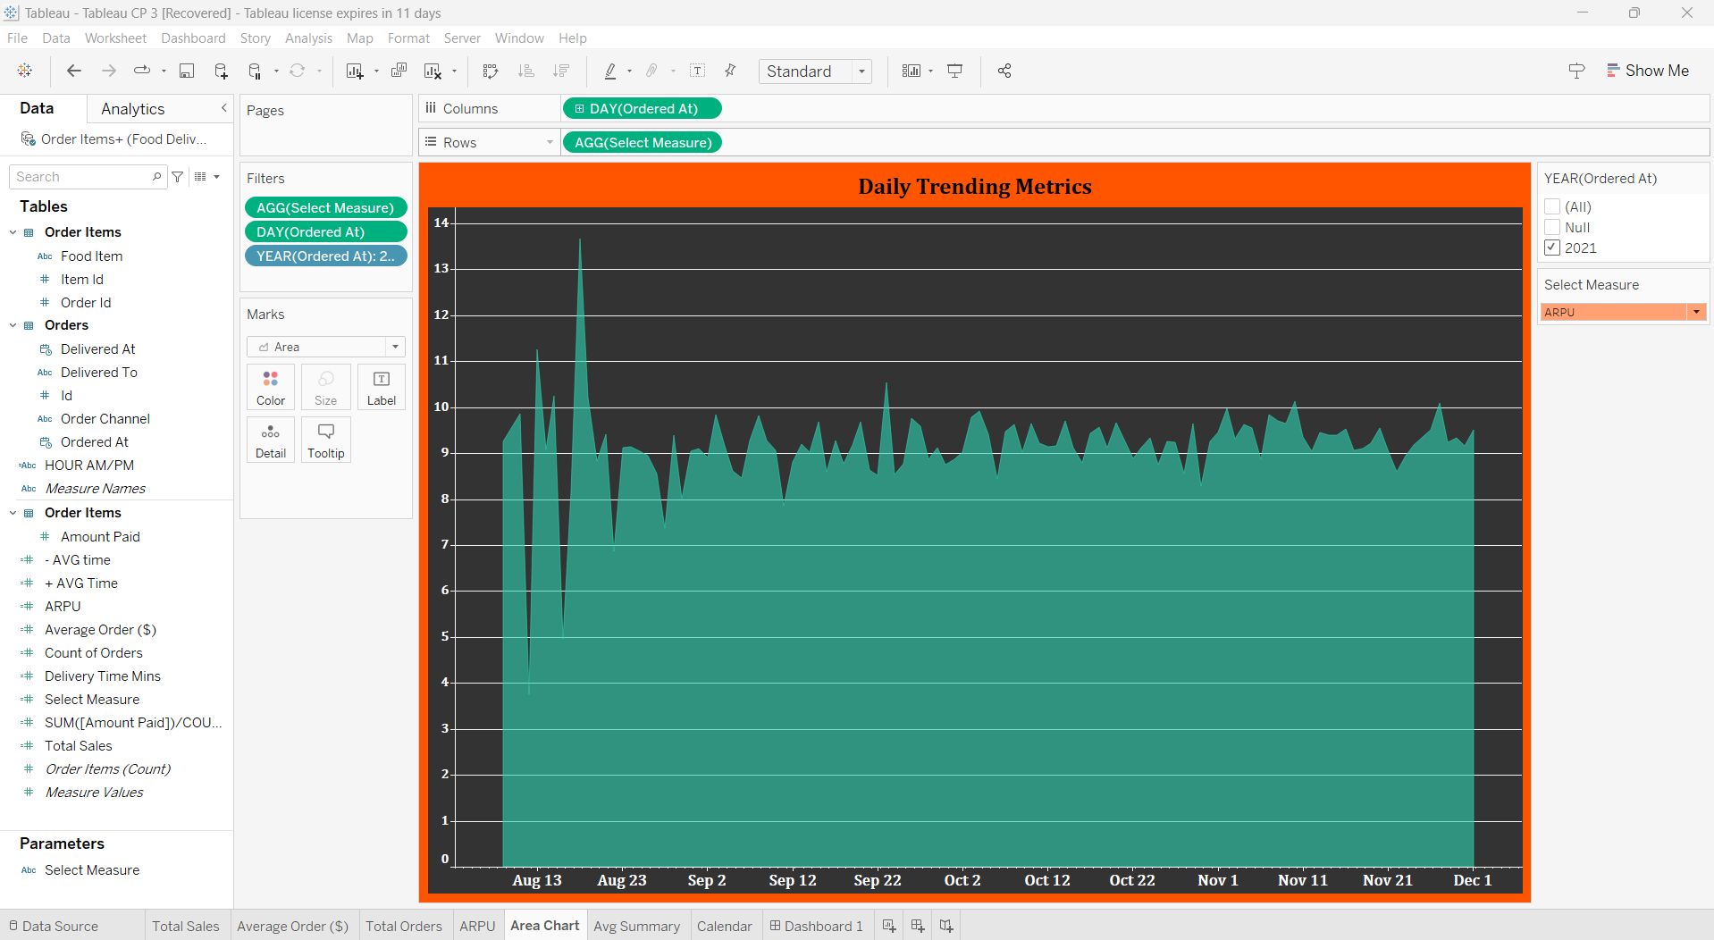

**View 6: Mins taken on an average for a Delivery or Pick up depending on the selection**

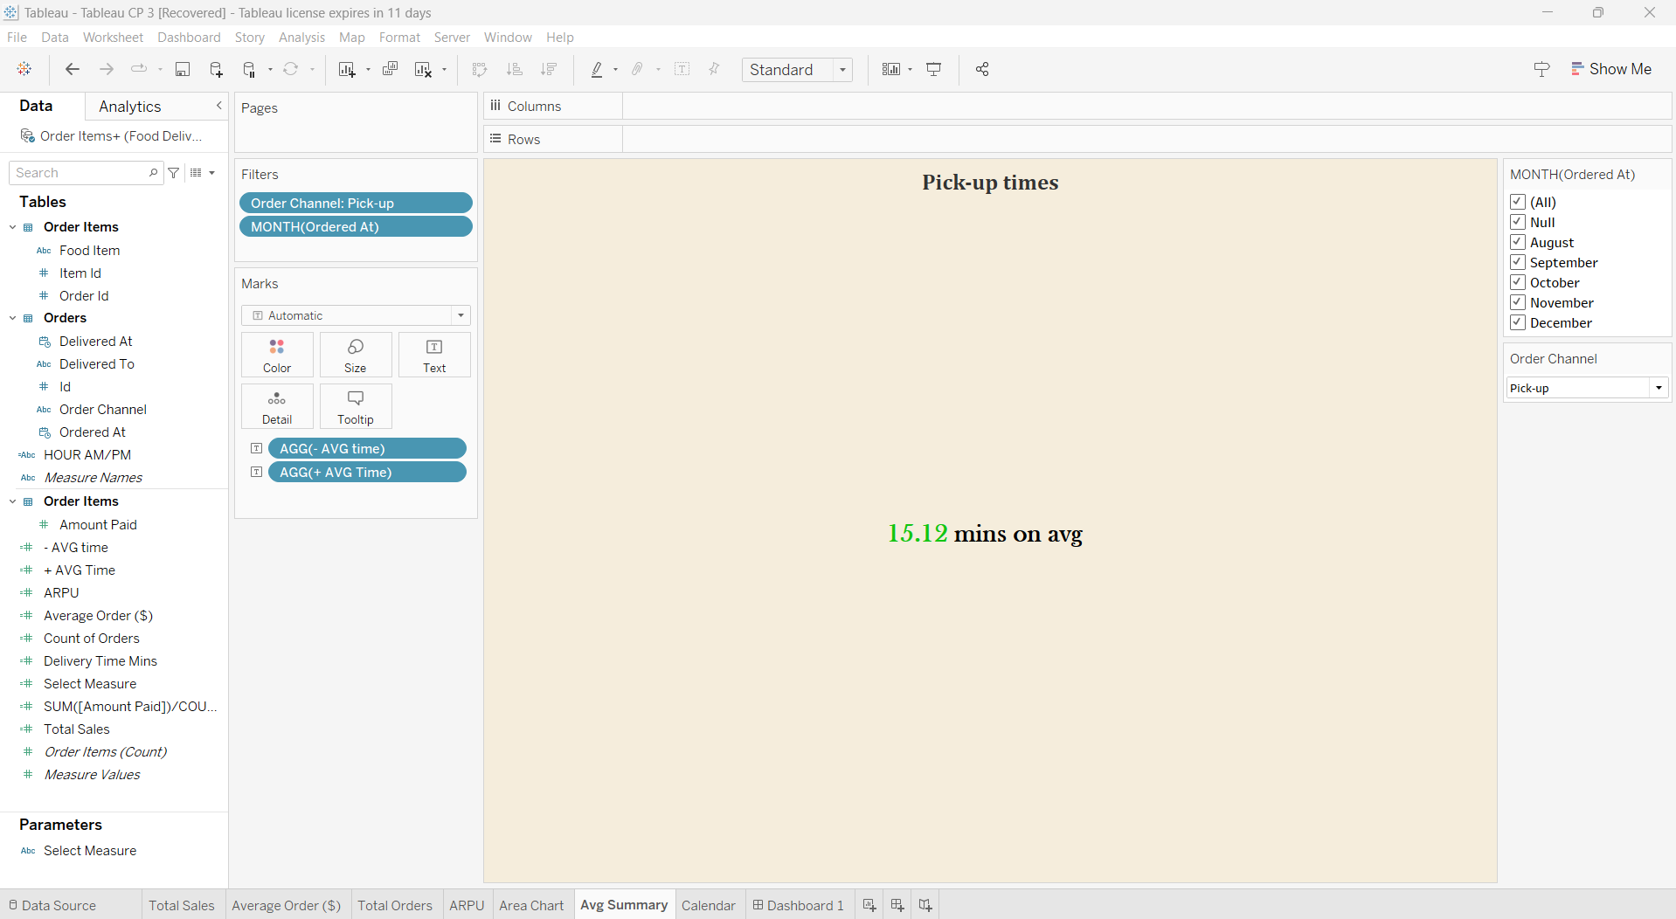

**View 7: Mins taken on an average for a Delivery or Pick up depending on the selection**

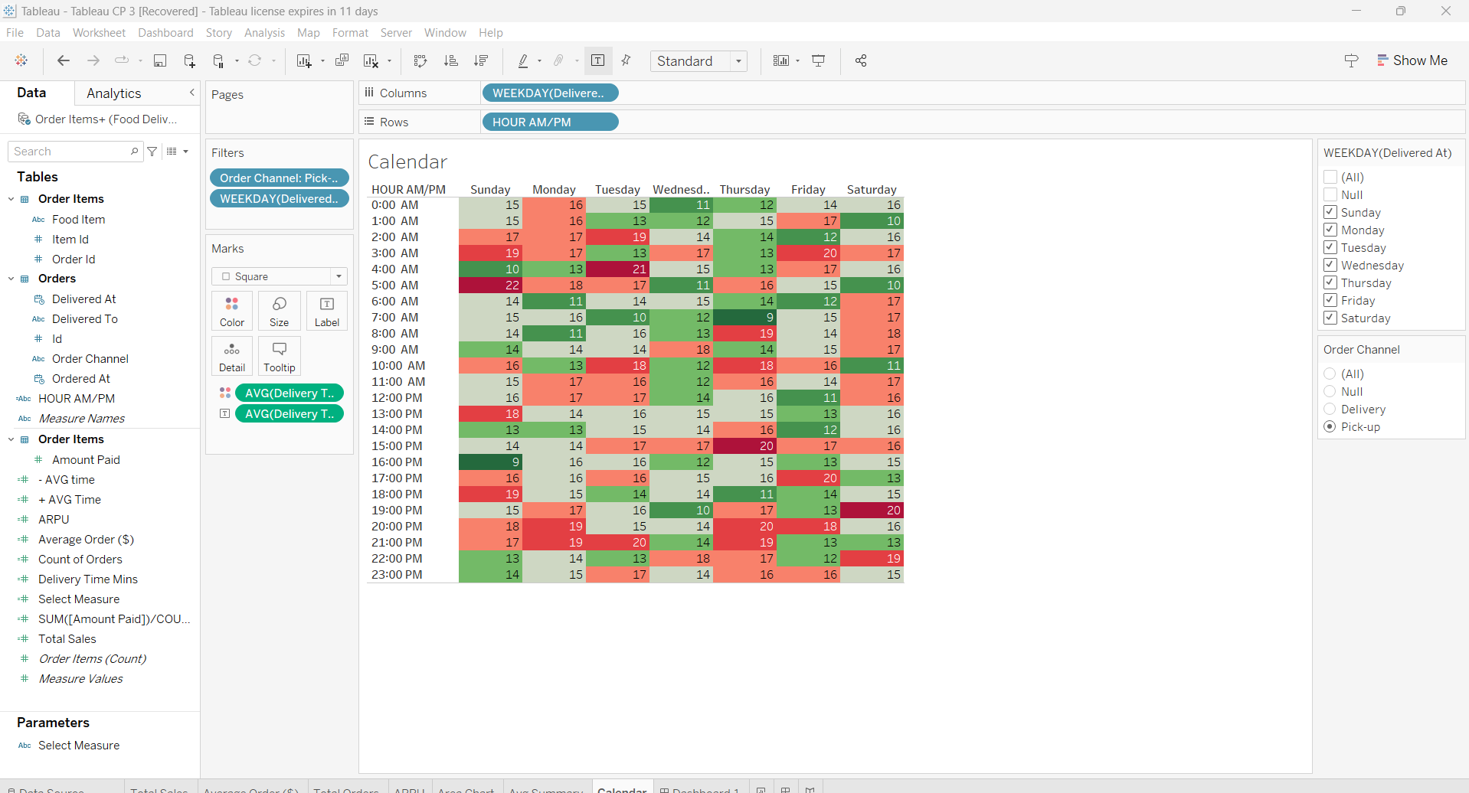

**DASHBOARD**

